Pre-processing of TR-PES data

# Identification of proper pre-processing procedures

Two steps are investigated: grouping the spectra together, and averaging them over a moving window

Results displayed here are for the file: NREL1_TRPES_Pb4f_40mW_0003_ATR_00000_00000_

Measurements are aggregated per 10, 20 or 40.

Averaging is applied over a moving smoothing window (successively centered over each measurement). Three sizes are considered. Gaussian filter computes a weighted average with Gaussian shape.

Averaging filters are applied over aggregated measurements (dashed lines) or directly to original data

Aggregation over 10 neighbors, averaging over 10, 20 or 40 aggregated measurements:

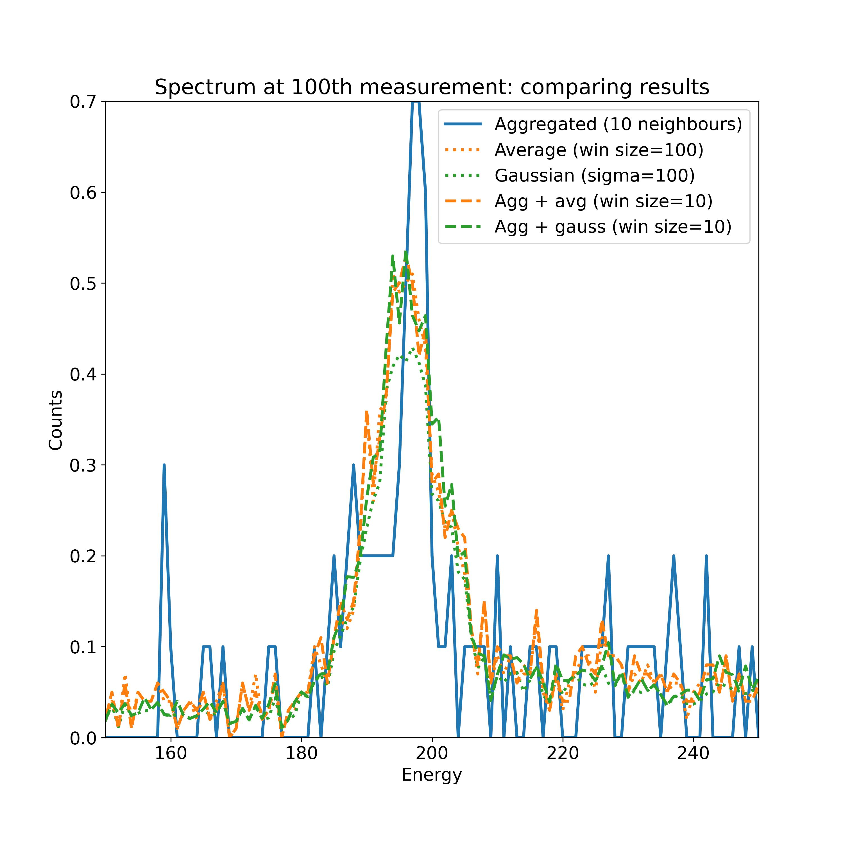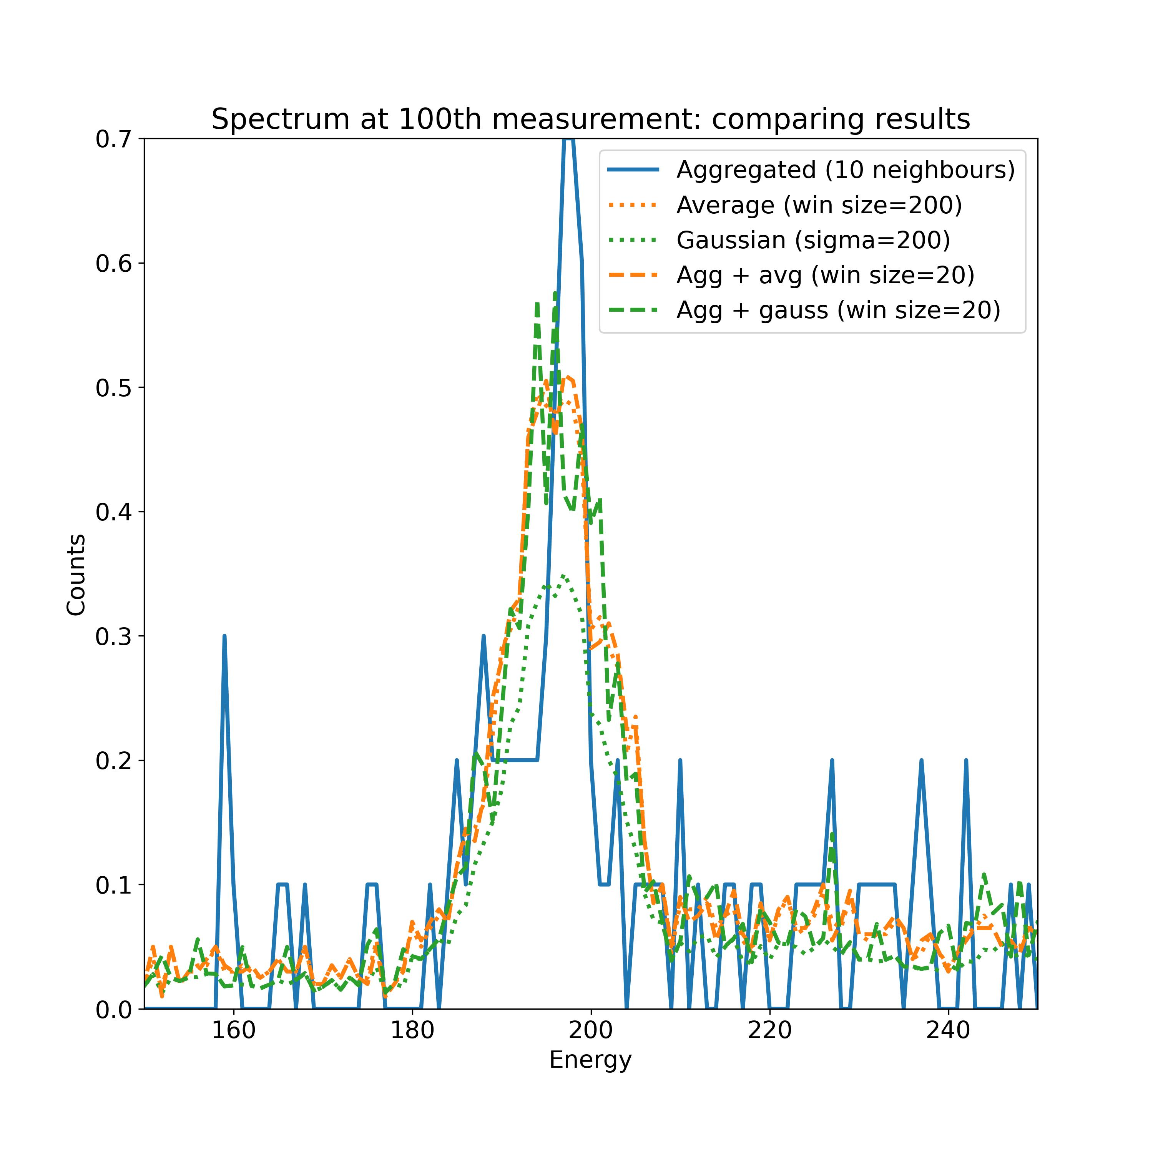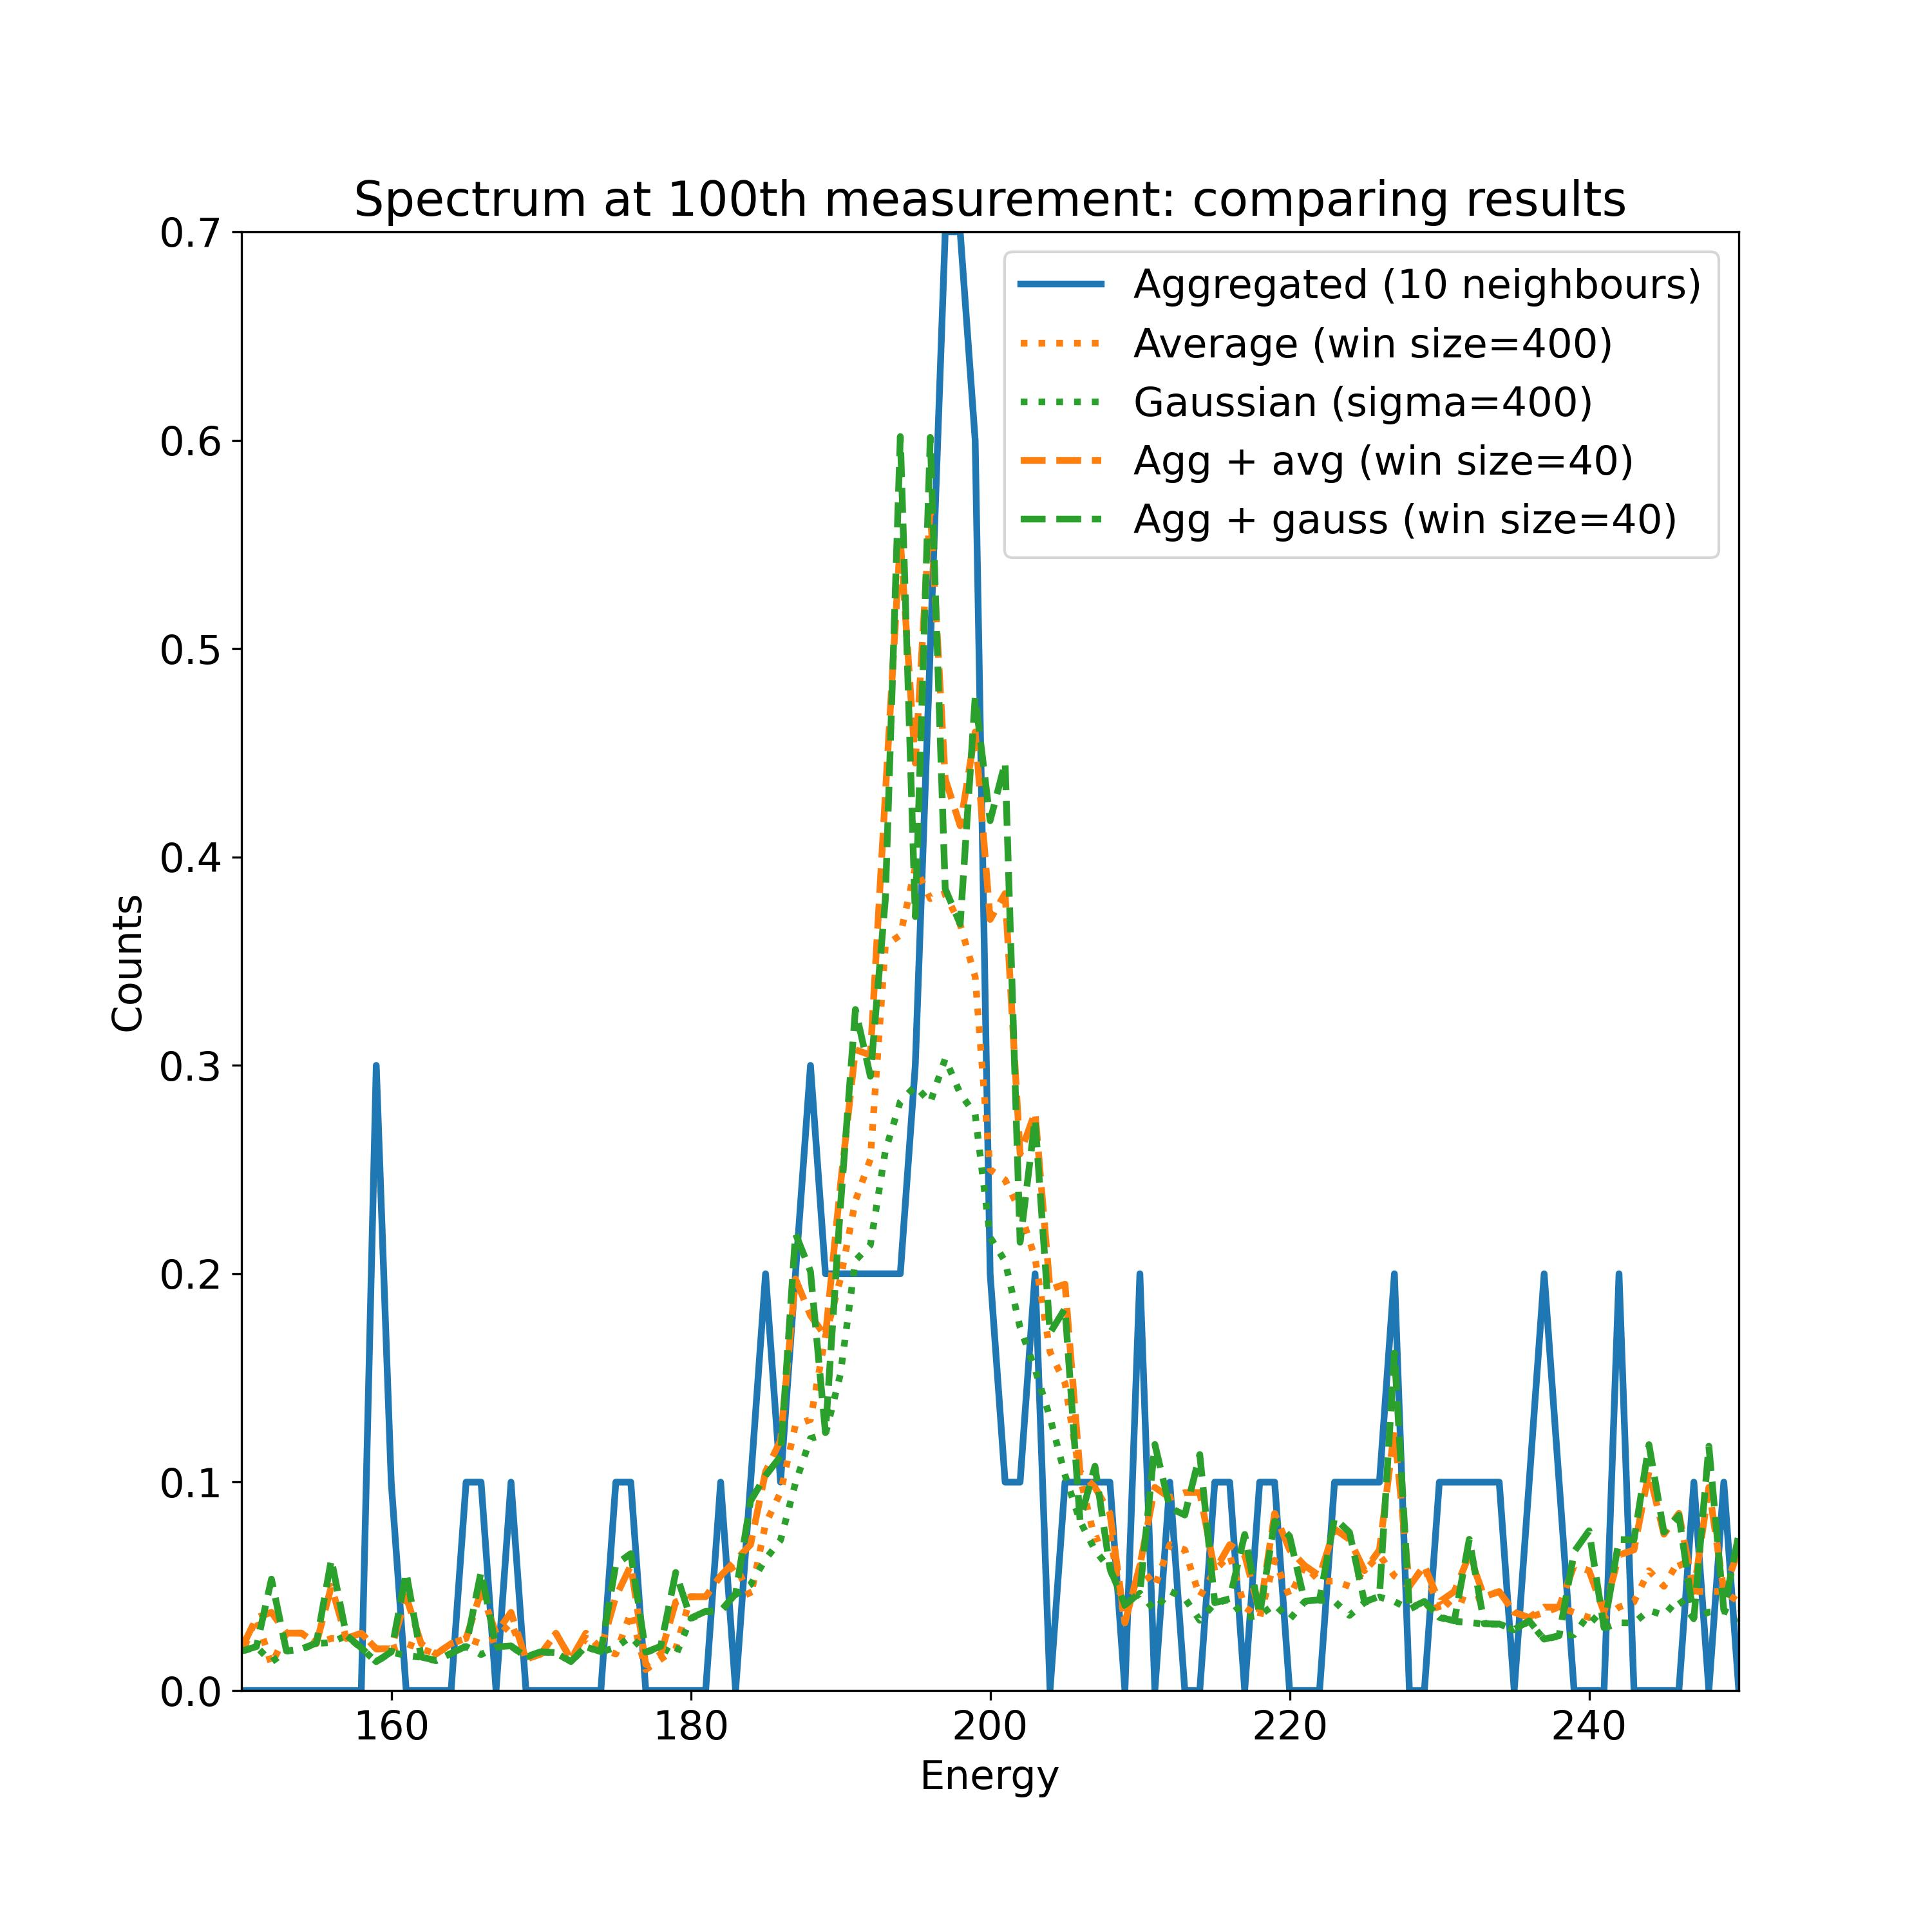

Aggregation over 10, 20 or 40 neighbors, averaging over 10 aggregated measurements:

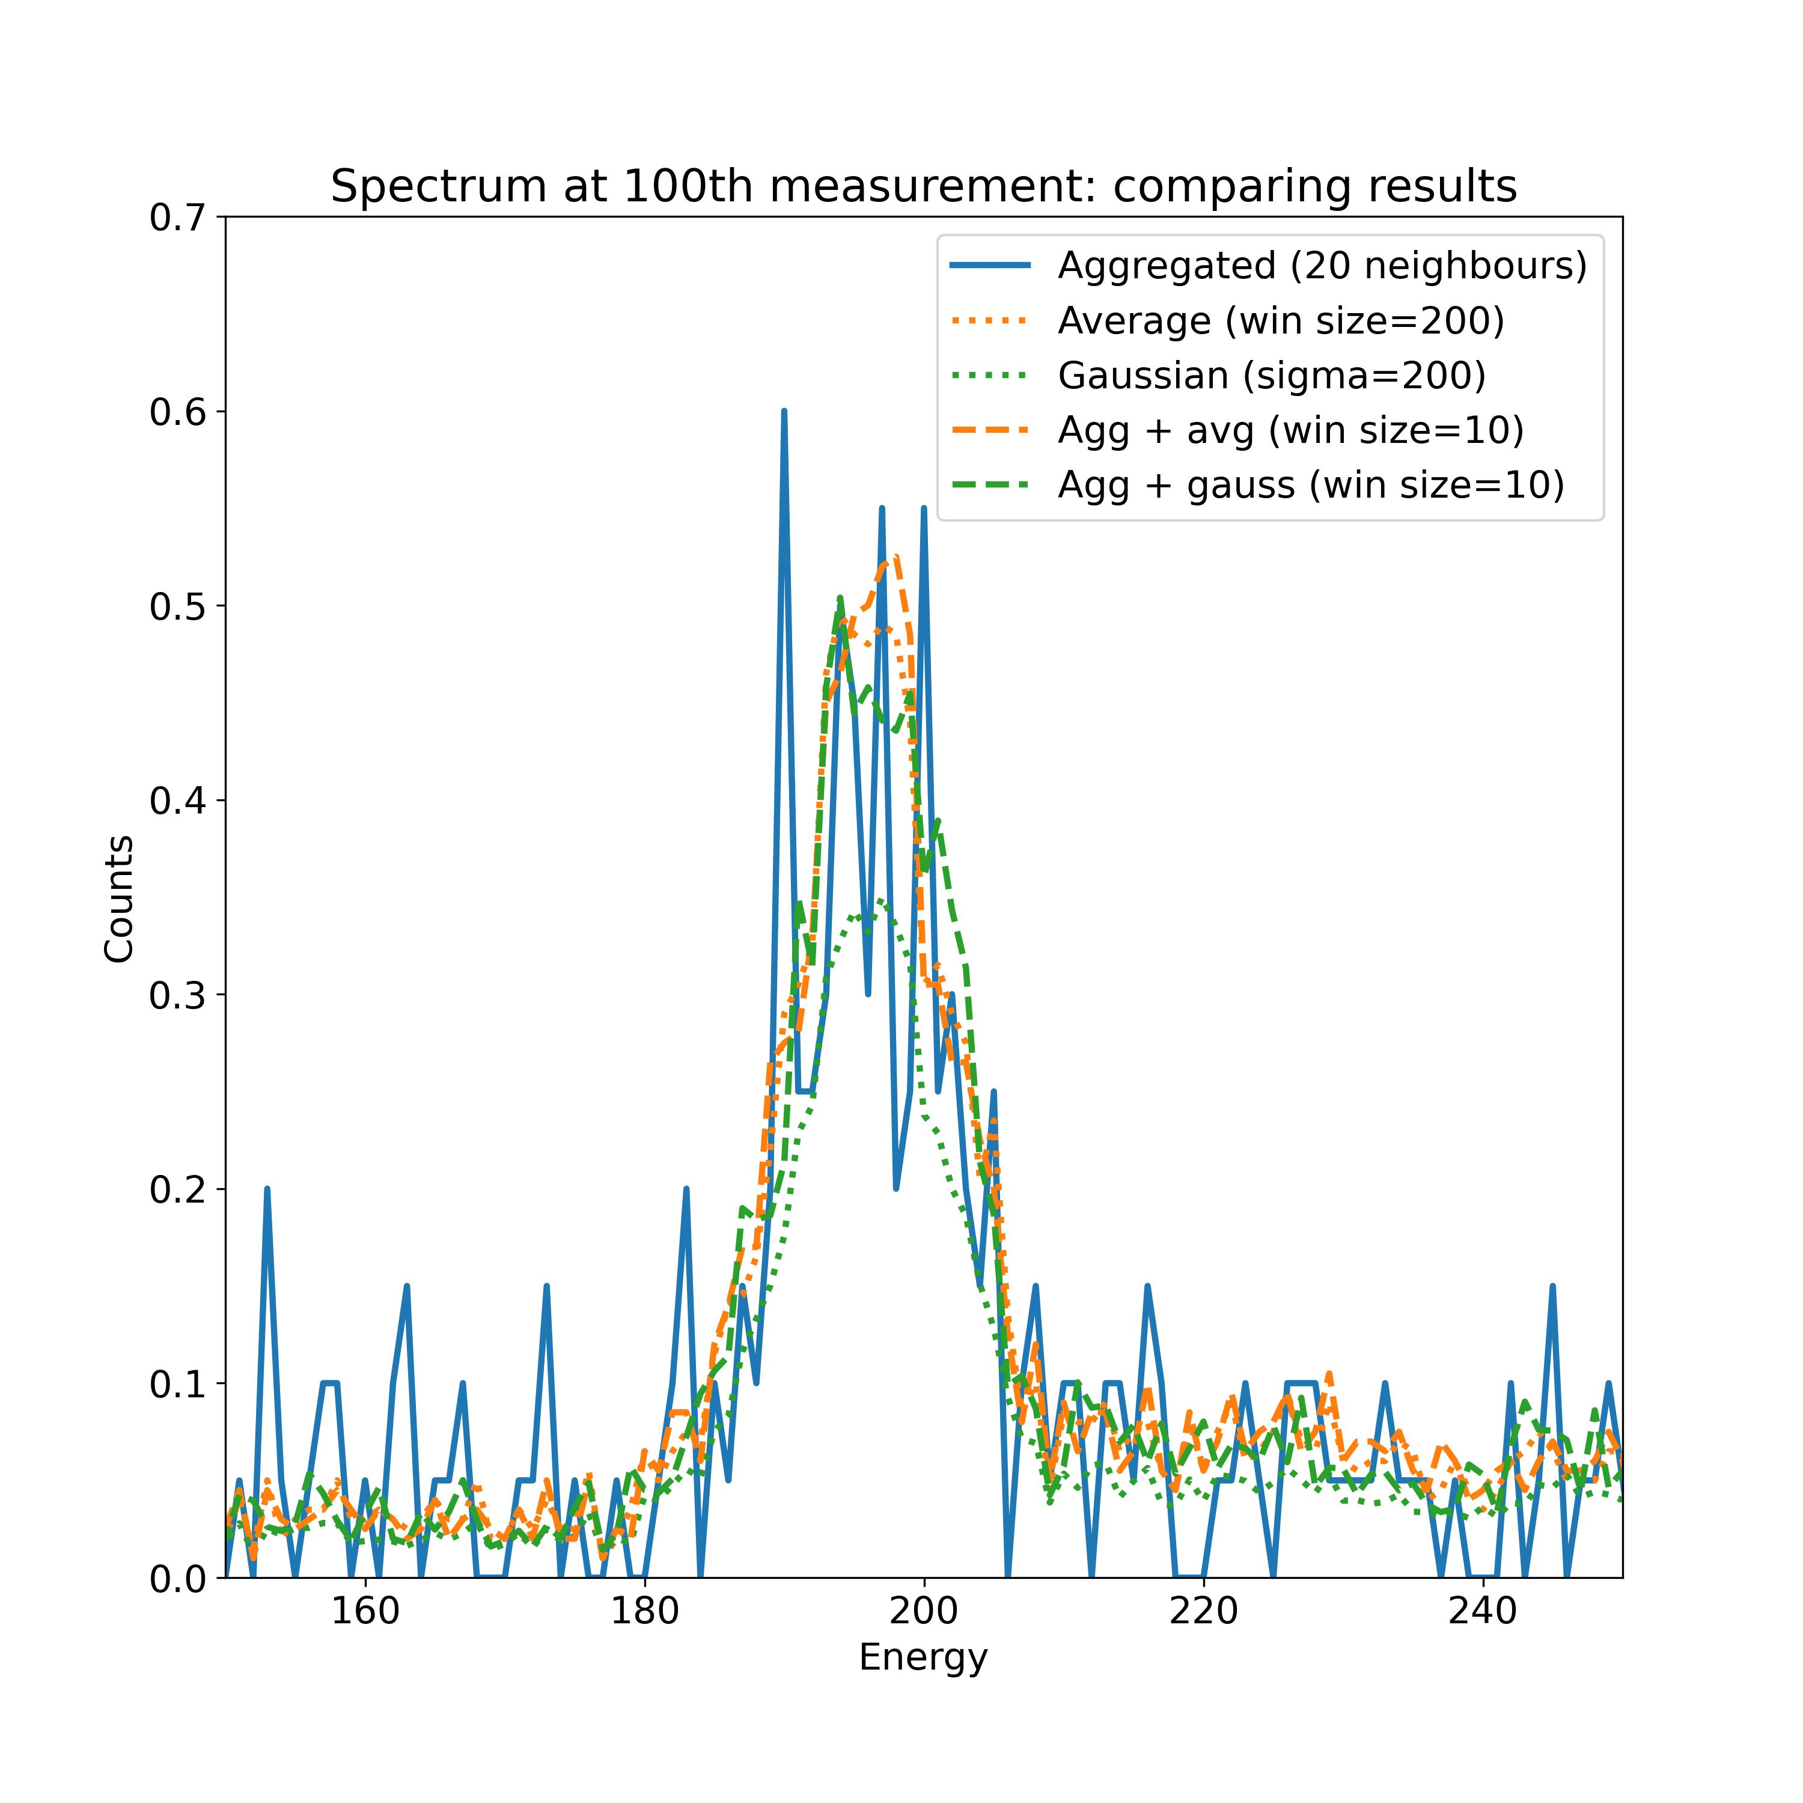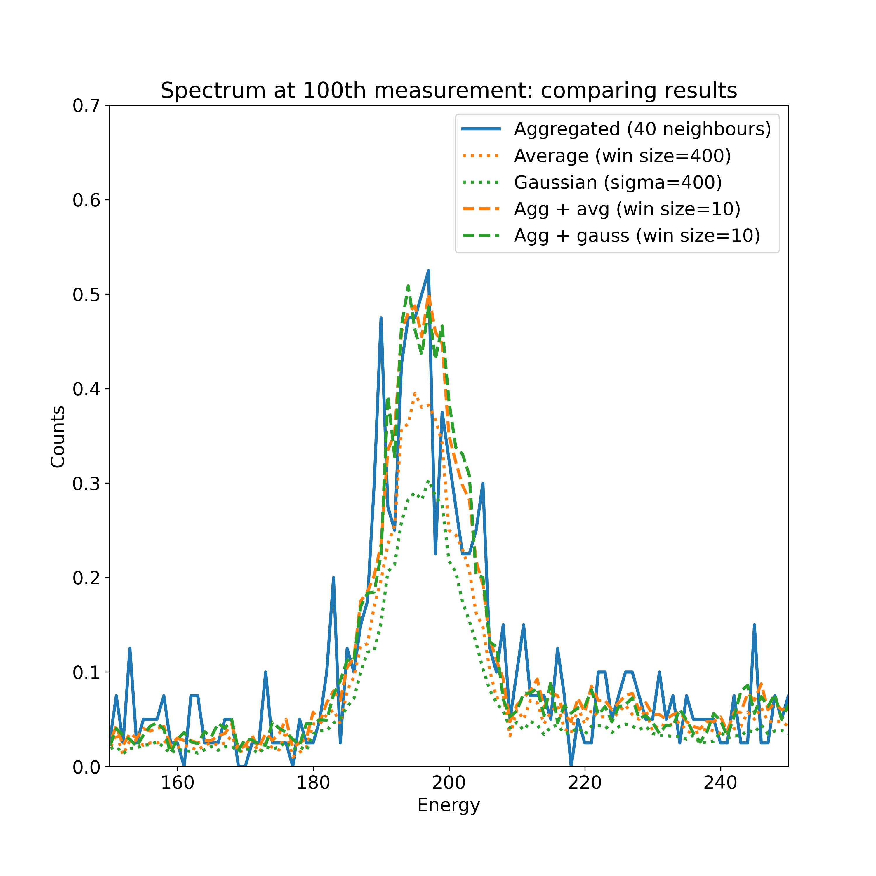

Clear issues when averaging is done without prior aggregation. Windows (chosen to be coherent with coupled aggregation + averaging case) are too large and distort data.

**Coupled aggregation + smoothing should be employed.**

In coupled aggregation + smoothing cases, no clear difference between simple average or Gaussian weighted average.

**Simple average should be employed.**

Two configurations to employ for fitting:

|  |  |
| --- | --- |
| Aggregation over 20 neighbors, average over 20 aggregated measurements  Results contain 255 time points | Aggregation over 40 neighbors, average over 20 aggregated measurements  Results contain 128 time points |